Fixed the next button – logic problem before

Fixed sixing of the frames all fit together window smaller to fito on more monitor screens using pack instead of grid for the frames

Added profit to it

Added notes to assets frame – disappeared when I bought or sold anything

Login is case sensitive – BEFORE GRAPH CHECK POINT

Made graph show on GUI however using the gui ie pressing buttons never loads all functionality of gui freezes when anything is pressed broken 0file

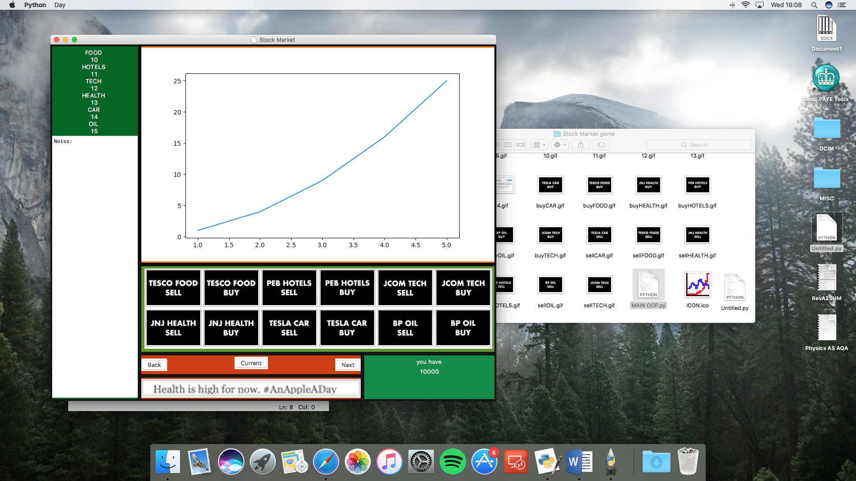

Made graph show on gui but needs code twice idk no error comes up but gui doesn’t come up either when I get rid of one copy

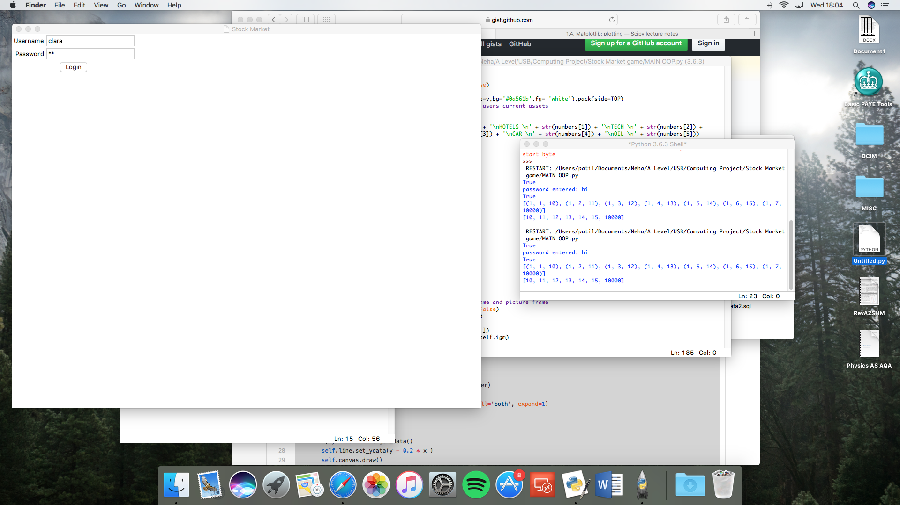

when I tried graph in separate window and nothing loads ut no errors file broken 1

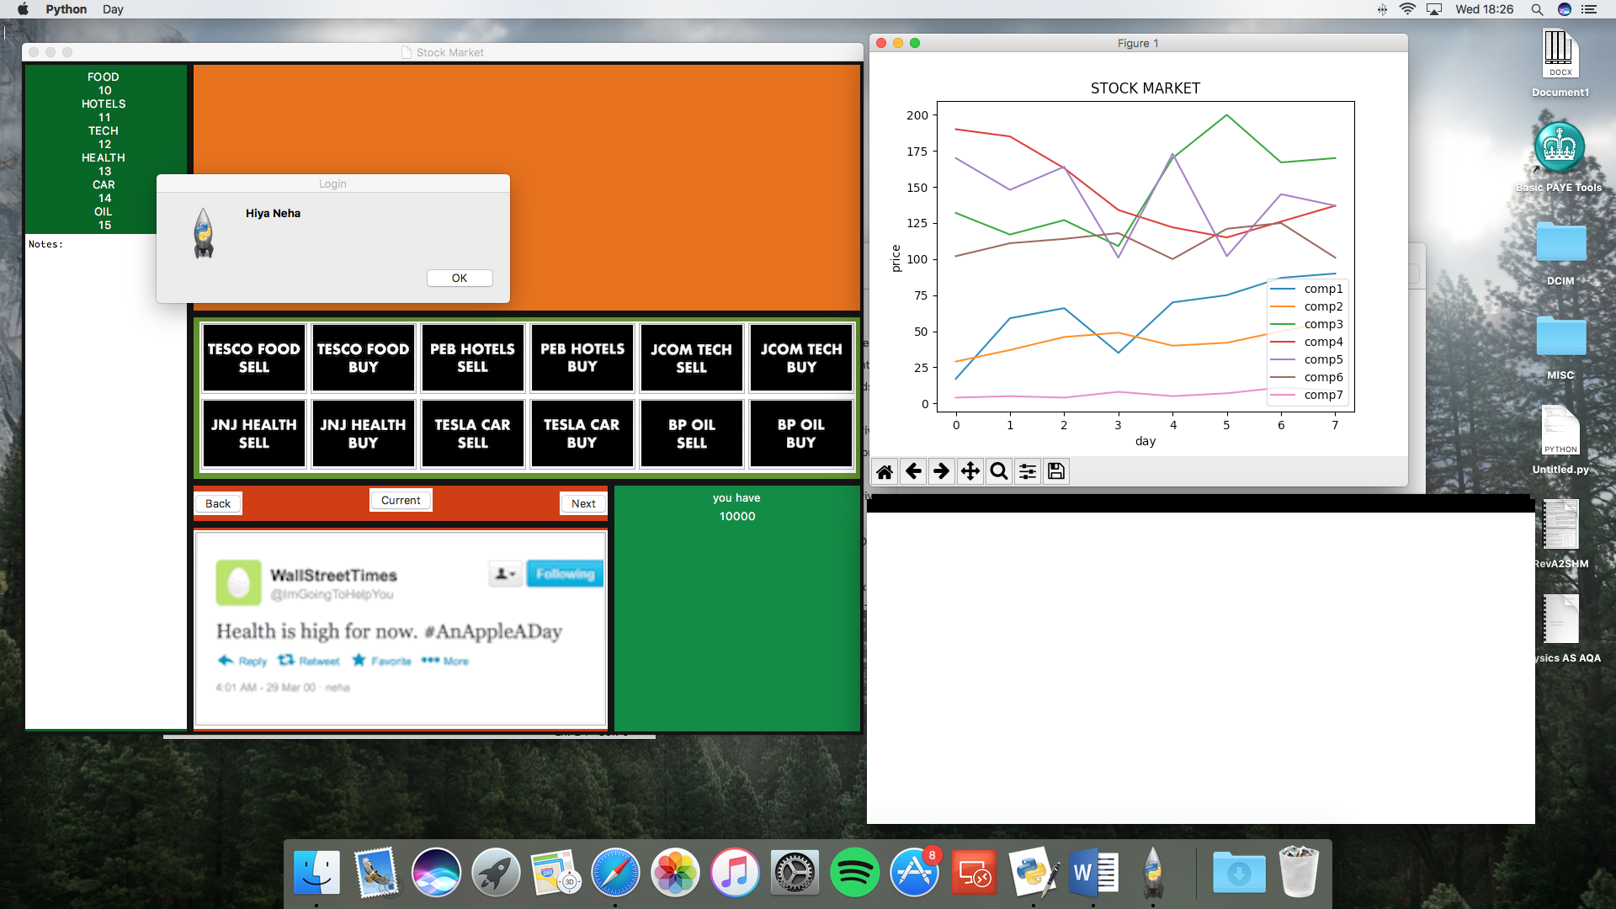

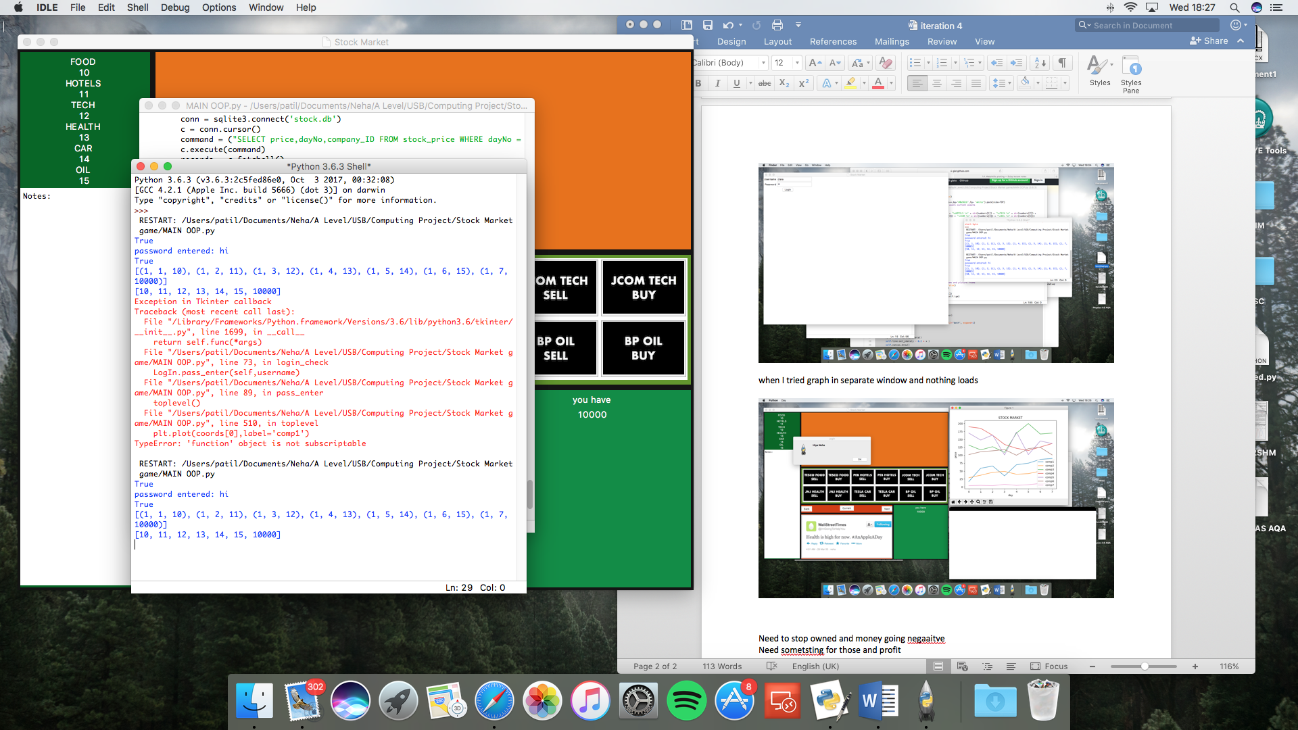

Need to stop owned and money going negaaitve

Need sometsting for those and profit

NEW PROBLEM tried opening the fraph in another file when you log in

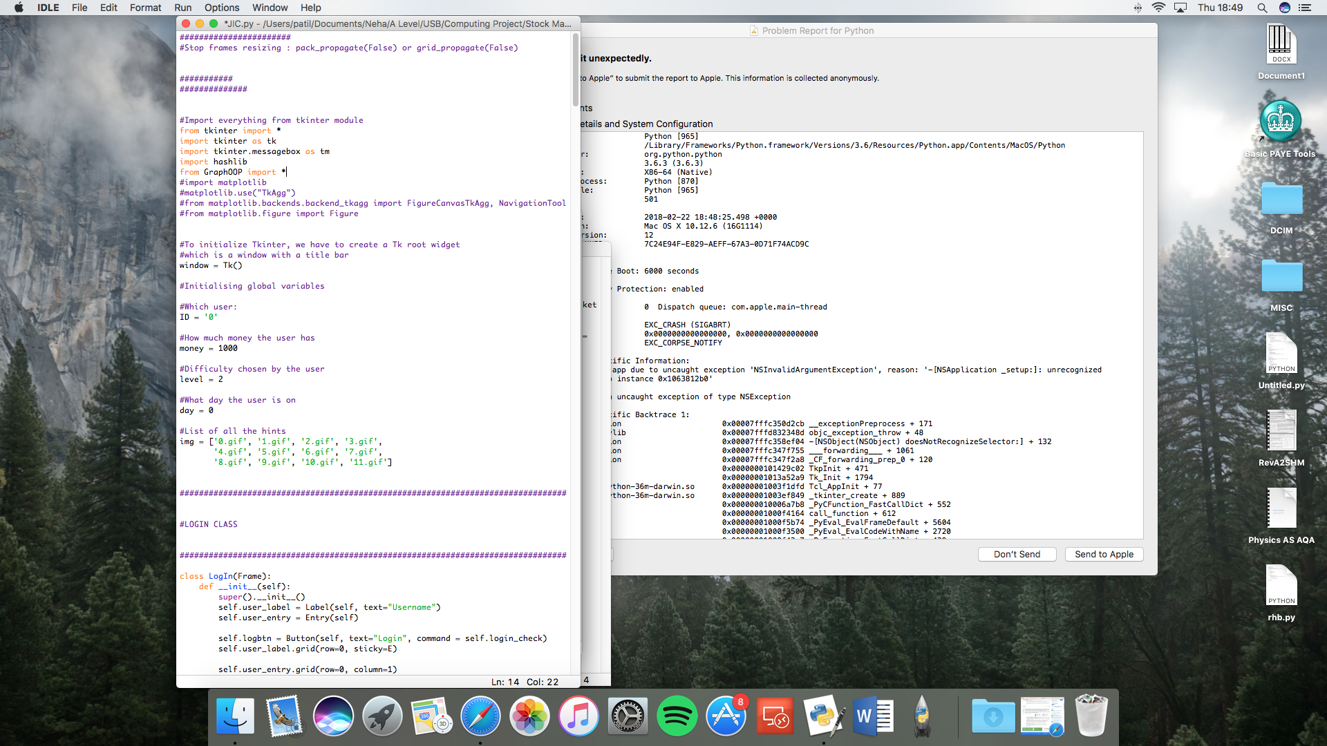

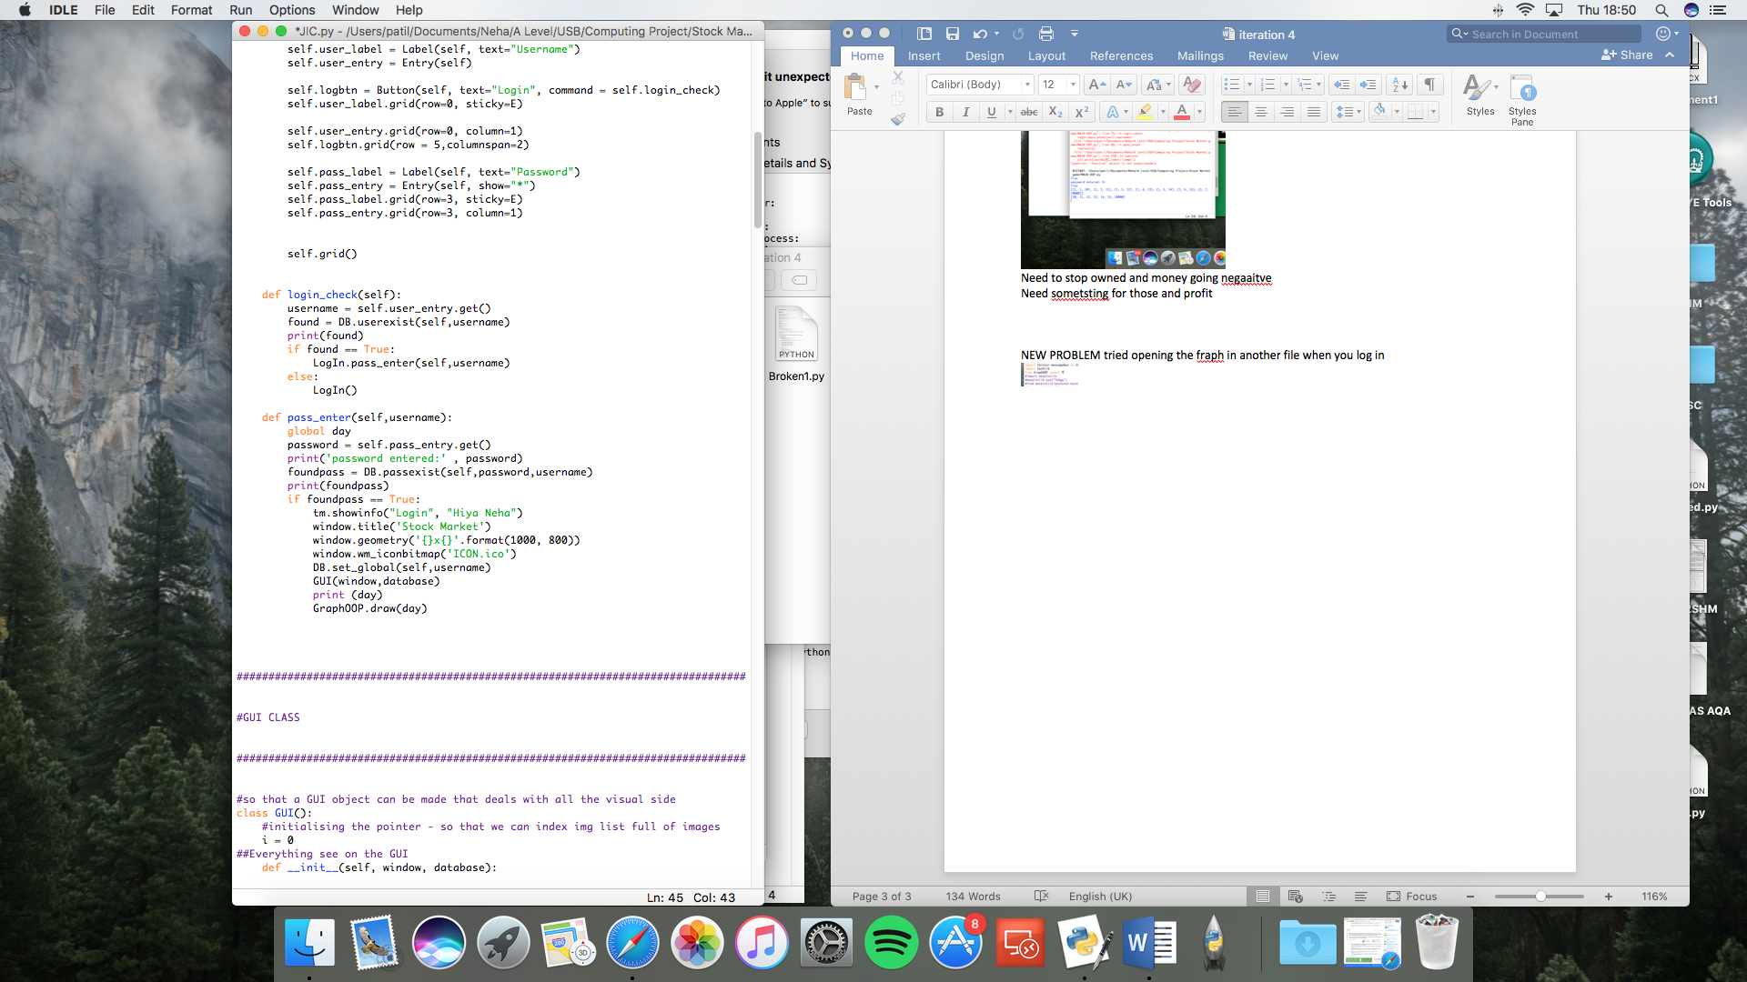

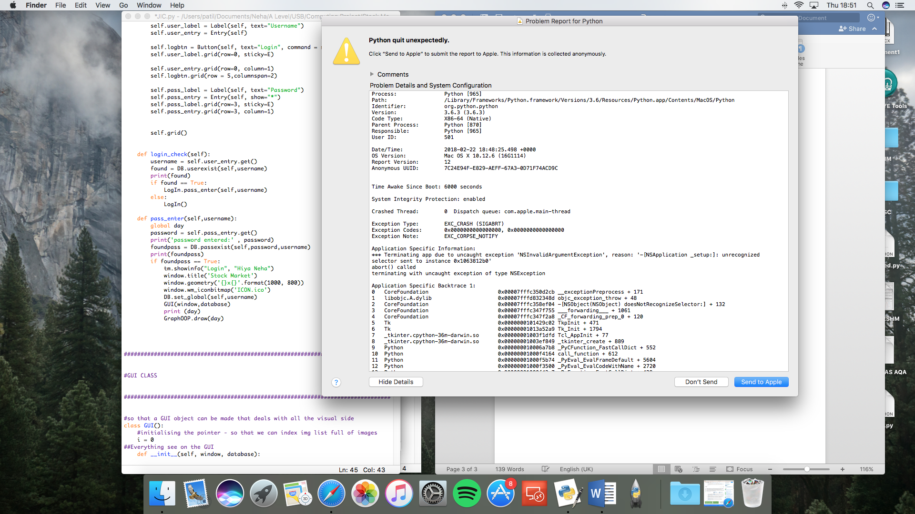

check broken 2 and graphOOP3 talk about __pychashe__ folder that was made

NEXT ISSUE

Made a completely new file where the day was entered manually , had a new day button that should refresh th graph but instead evrytime the button clicked a new window opened : check graphOOP4

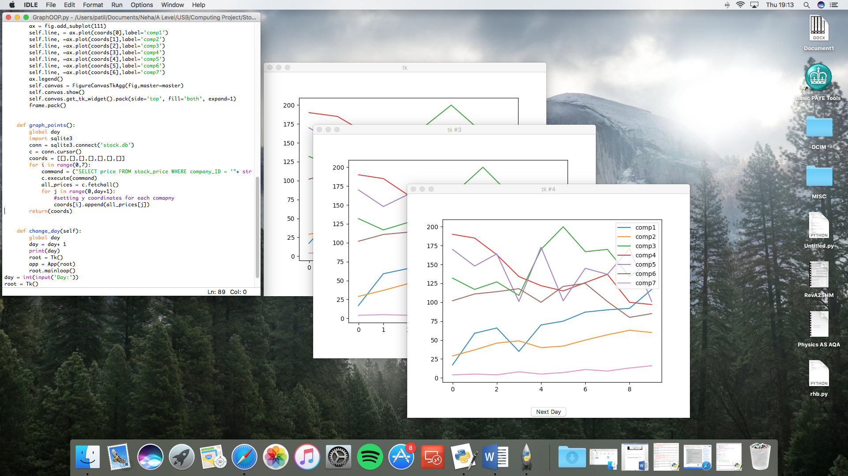

I did it as a button learnted about top level widget – user can look at the graph and when they are done with that day they can close the graph and change day and then click again for an updated graph - AFTER GRAPH CHECK POINT – HAD TO ADD A WHOLE NEW GRAPH CLASS

Gonne need a gui redesign – big gap thinking about putting stats there

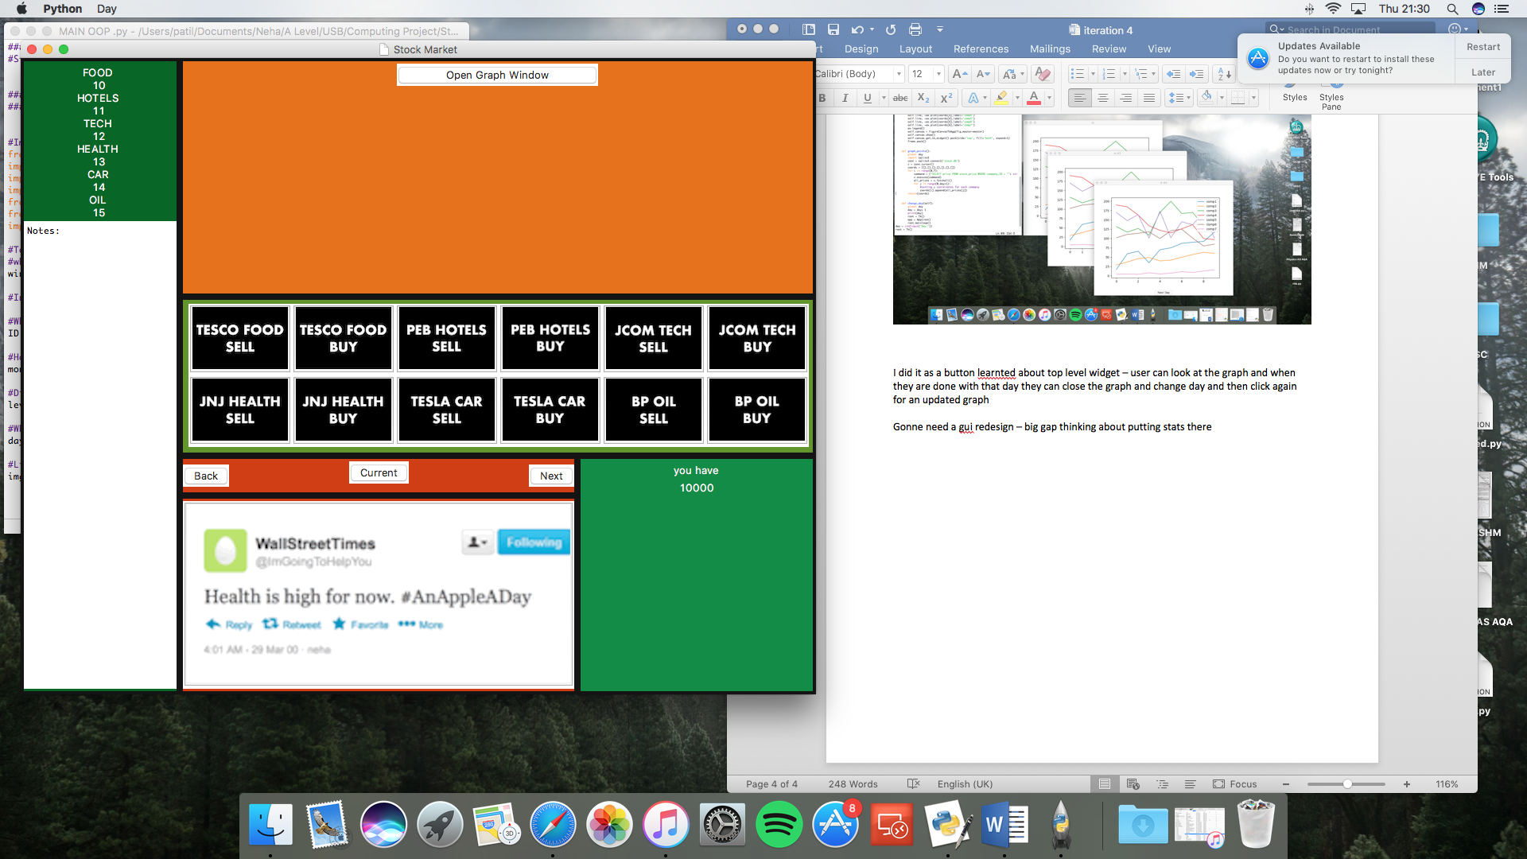

the notes thing has a problem every time the assets frame gets refreshed ie every time you buy and seel something it keeys getting cleared so gonna give it its own frame

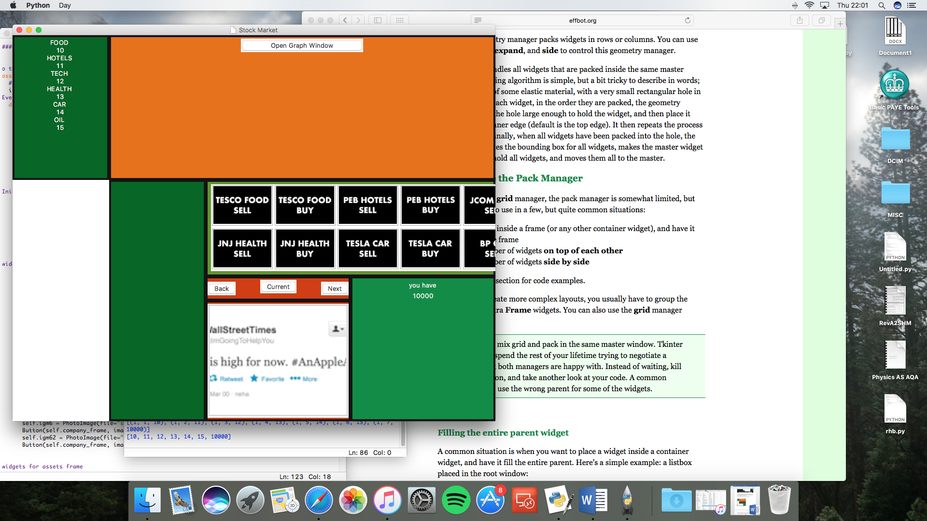

The **Pack** geometry manager packs widgets in rows or columns. You can use options like **fill**, **expand**, and **side** to control this geometry manager.

The manager handles all widgets that are packed inside the same master widget. The packing algorithm is simple, but a bit tricky to describe in words; imagine a sheet of some elastic material, with a very small rectangular hole in the middle. For each widget, in the order they are packed, the geometry manager makes the hole large enough to hold the widget, and then place it against a given inner edge (default is the top edge). It then repeats the process for all widgets. Finally, when all widgets have been packed into the hole, the manager calculates the bounding box for all widgets, makes the master widget large enough to hold all widgets, and moves them all to the master.

**When to use the Pack Manager**

Compared to the **grid** manager, the pack manager is somewhat limited, but it’s much easier to use in a few, but quite common situations:

1. Put a widget inside a frame (or any other container widget), and have it fill the entire frame
2. Place a number of widgets **on top of each other**
3. Place a number of widgets **side by side**

<http://effbot.org/tkinterbook/pack.htm>

so back to grid woop woop because things wont fit under eachother otherwise e – no need to specify size when using rid

bank now shows interest for that day and the amount of money you will get from them if you choose to save tha day, this updates as you buy and sell stock

now making it so the the hint you see if your most recent when you log in

now I want to add a frame that shows the percentage change of each stock and the amount

lost / gained

two new frames the notes frame and the stats frame

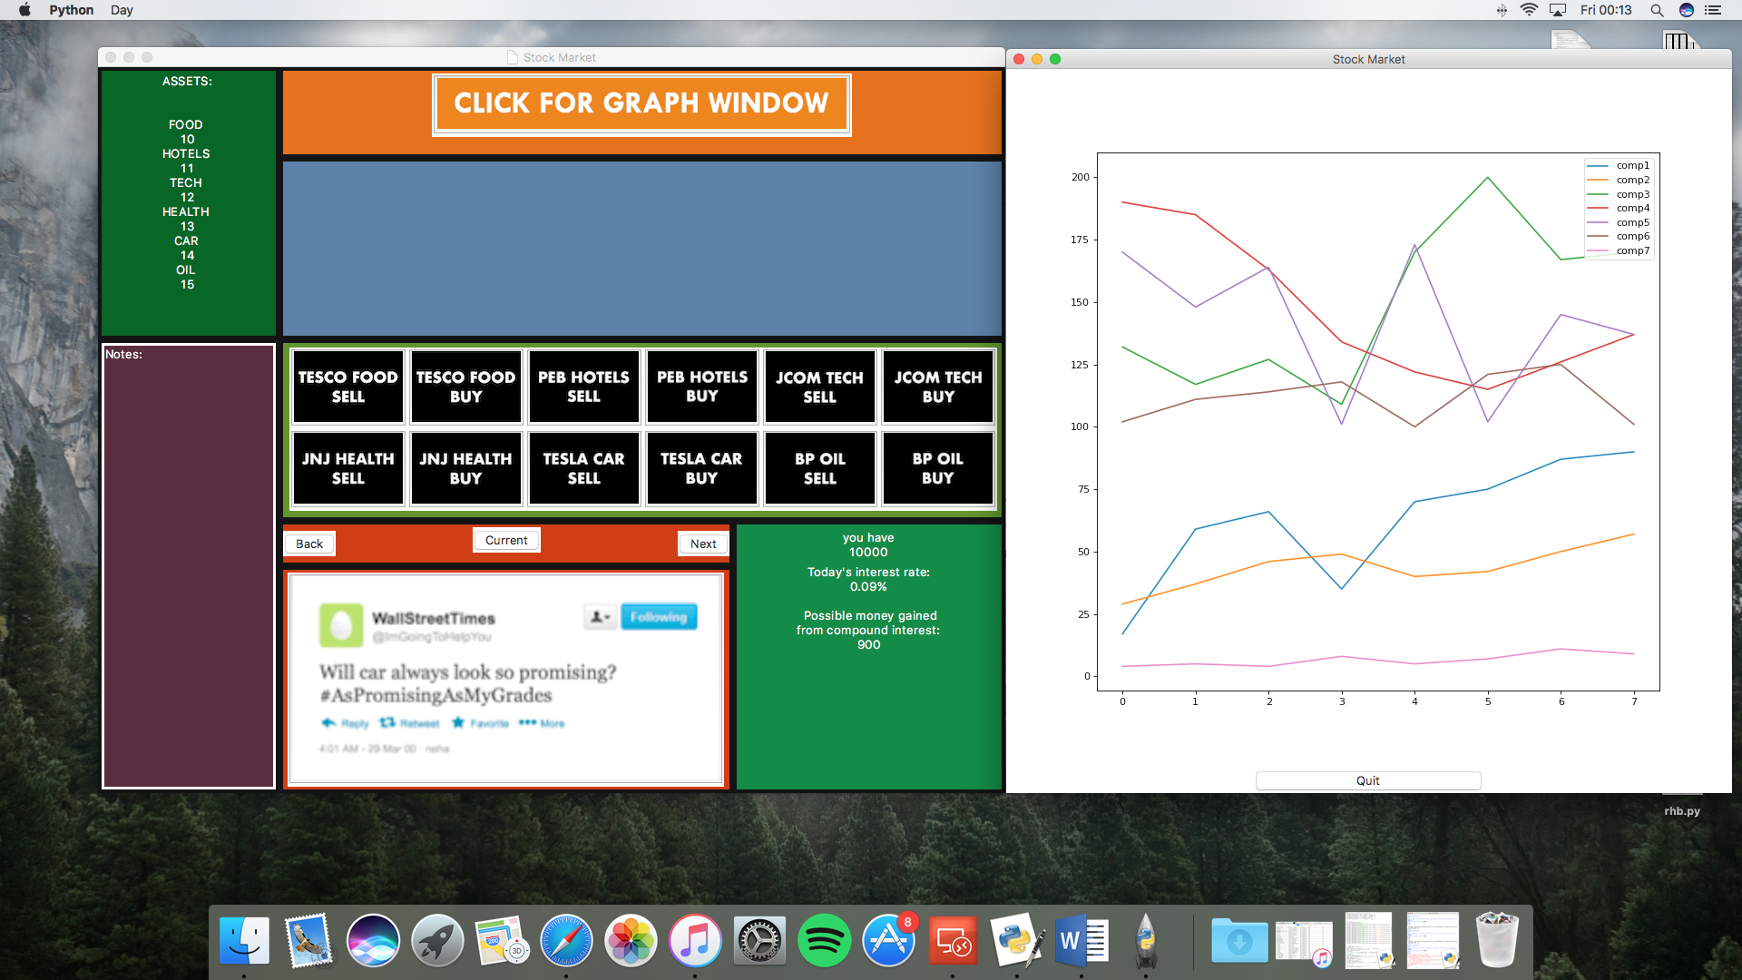

got stats frame to work out shoes the percentage change of each stock and shows how much money user has lost or gained from yesterdays trading , when it first initialised sats ‘play game for stats ‘ need to develop the database so it stroes the previous days stast so even that bit is seamless , also need a save button

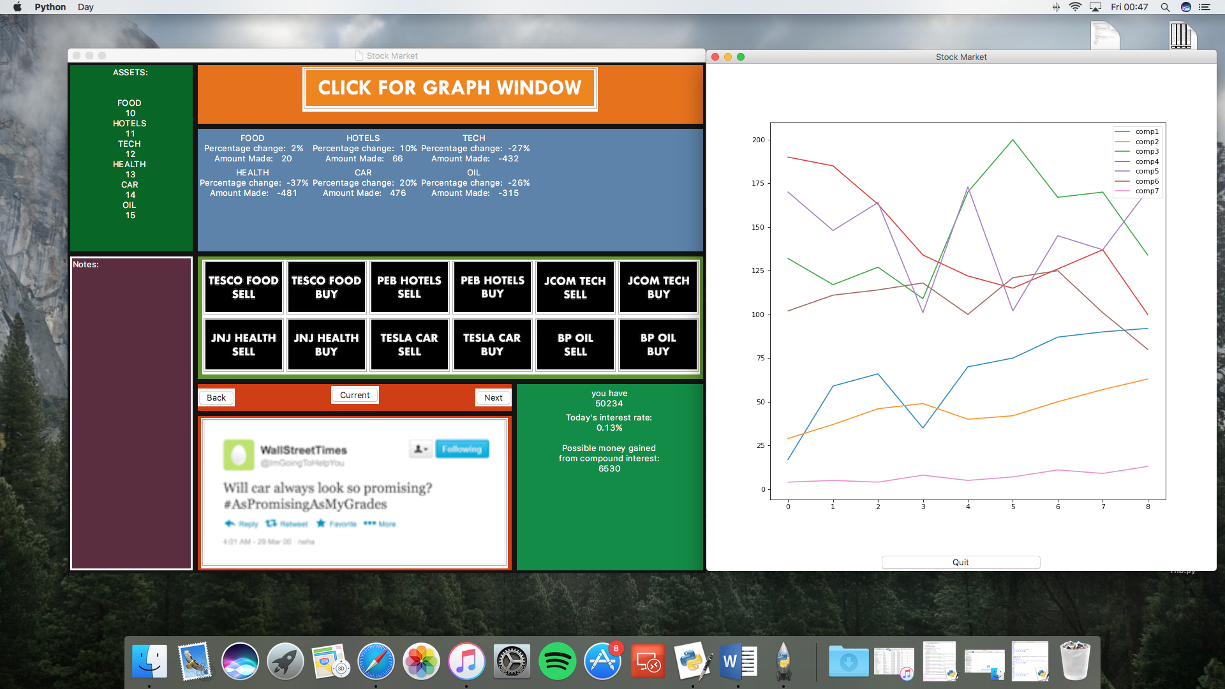

comp6(Oil)

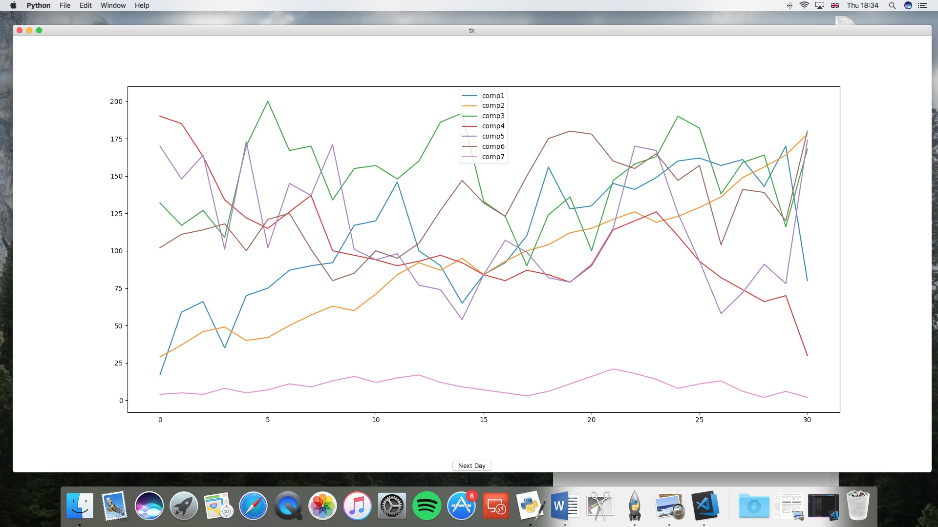

Beta:

Wording of what all the numbers mean can be clearer

Leave more space between all the numerbs

Add an image to make it more user friendly

Instructiosn on how to change the dat ect should apprear

Change / desirable :

As beta said ad an image would be cool to have a character or mascot that explains the game and helps you algon may appeal to younger stakeholders

(((maybe put the change day button in that gap – talk in the evaluation how you didn’t plan a spot for the change day button)))